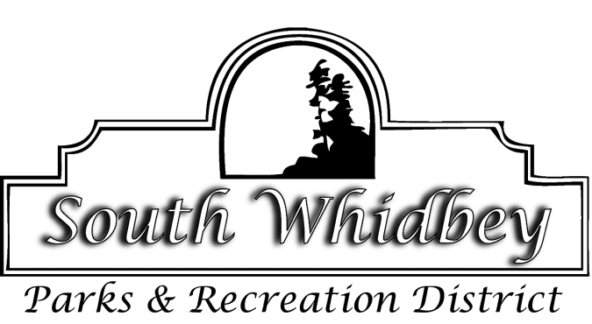
Memo
To: Board of Commissioners
From: Carrie Monforte
Date: 10/13/2022
Re: 2023 Budget Workshop

The budget workshop is for discussion purposes only. Any actions would need to be reserved for the regular meeting.

A few edits were made to the first draft of the 2023 budget. In addition to updates to 2022 year-end estimates, the following material changes were made to the 2023 budget figures.

Admin
- 4-2110 Levy updated - $1,301,885 became $1,828,898
  - Estimate based on value received in January: $1,301.885
  - Estimate based on value received in October: $1,590,346
  - Estimate based on recommended range for possible value increase in January:
    - 10% - $1,749,381
    - 15% - $1,828,898
    - 20% - $1,908,415
  - We inserted the 15% increase estimate, the board may choose to do otherwise. The District receives the lower of either the budgeted amount or the actual levy amount, this is why we add 15% to the calculations from October for the budget. The amount that we receive in 2023 sets the maximum base for what we can receive in subsequent years of the 4-year levy (plus 1% and new construction).
- 6-1010 Director $123,000 became $128,678 to account for the possibility of sick leave pay-out.
- 6-1012 Business Manager $76,373 became $79,899 to account for the possibility of sick leave pay-out.
- 6-1201 FICA $7,500 became $9,500
- 6-1202 SUI $1755 became $2600
- 6-1203 L&I $13,500 became $16,300
- 6-1301 Accounting Service $9,000 became $10,250
- 6-1428 Election costs projected for 2024 and beyond have been updated to include the possibility of invoicing being delayed for a November election and having to pay costs for multiple elections in one year.
Programs
- 6-4132 Basketball Expense $13,000 became $14,300
Loans
- Storage Building payment decreased from $12,724 to $12,117
- Toro Workman payment decreased from $7,082 to $6,745
- Jacobsen payments increased from $10,485 to $13,916 (final payment)
Capital Projects
- Layout of capital projects divided between what we had planned in 2021, vs new plans.
- Changed Concession Building roof from $20k to $30k
- Changed Park Improvements/Asphalt Improvements from $46K to $36K
Maintenance
- 6-2434 Fuel Increased from $10,000 to $11,000
Anticipated Updates in November
- Lease for Office Building
- Health Insurance
- Dental
- Possibility of moving Maint/Program wages out of Admin to their respective departments in order to align with our accounting system reports.

